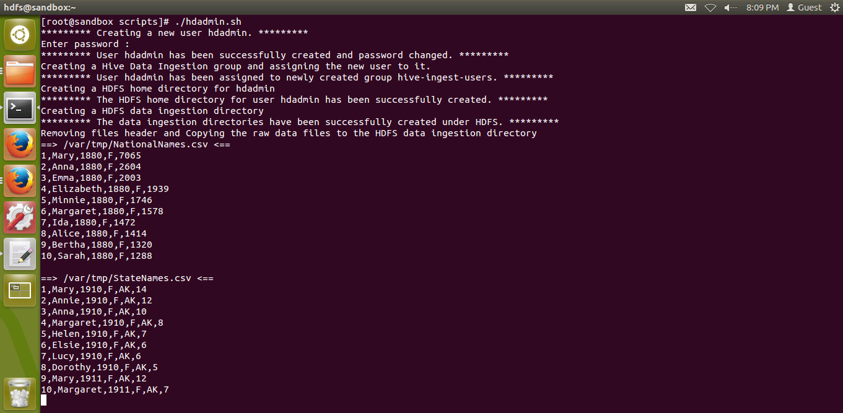

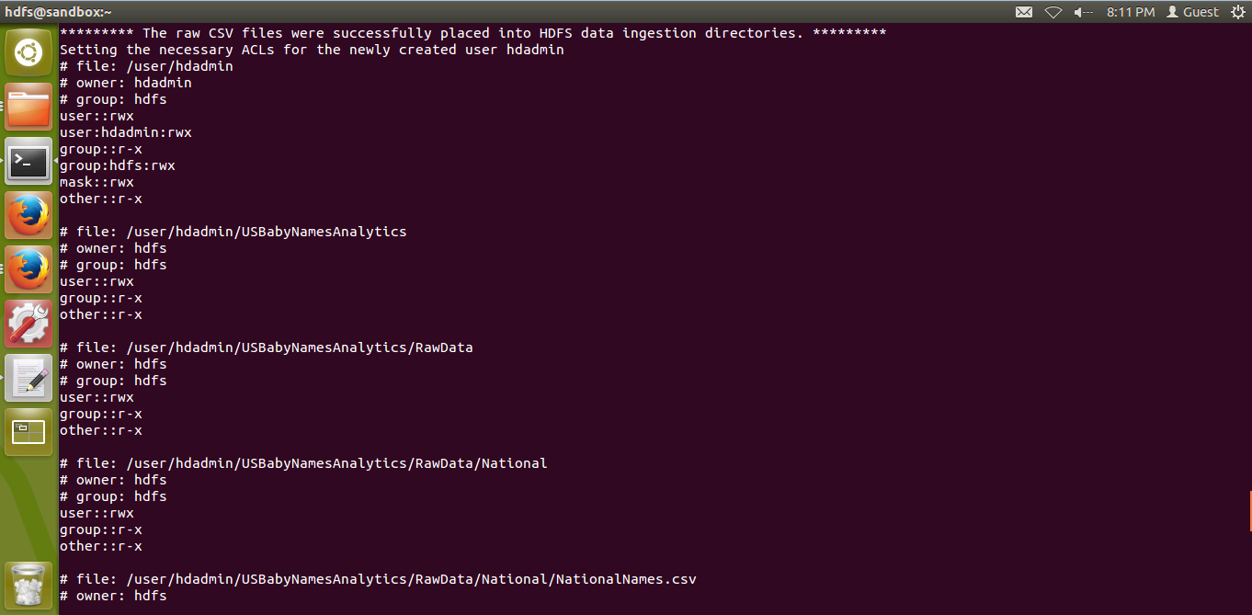

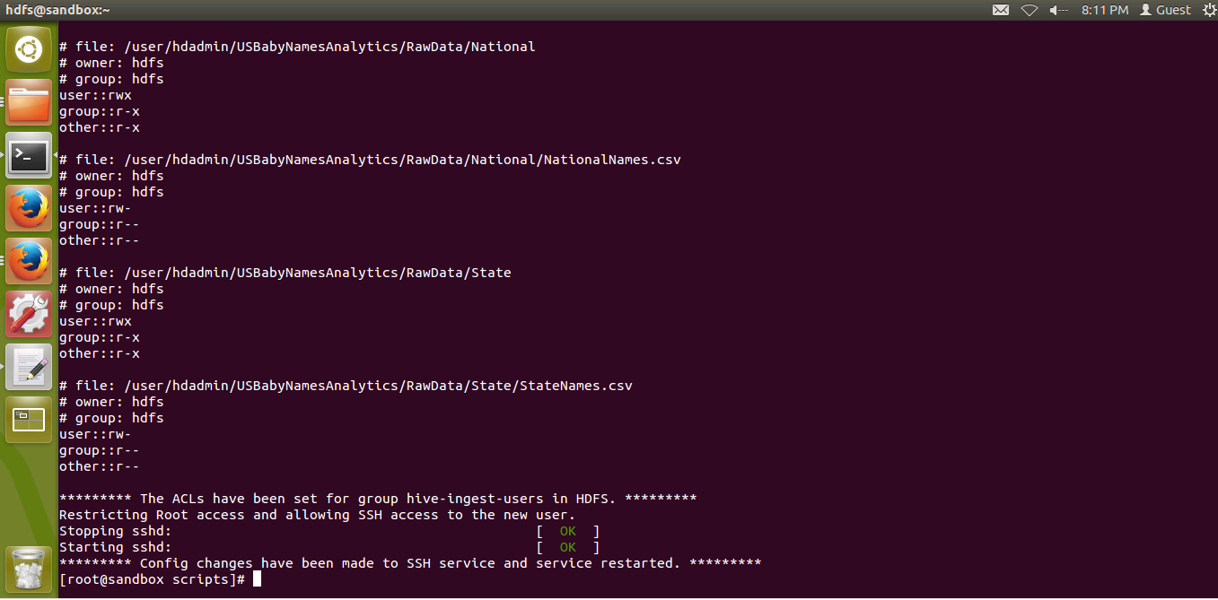

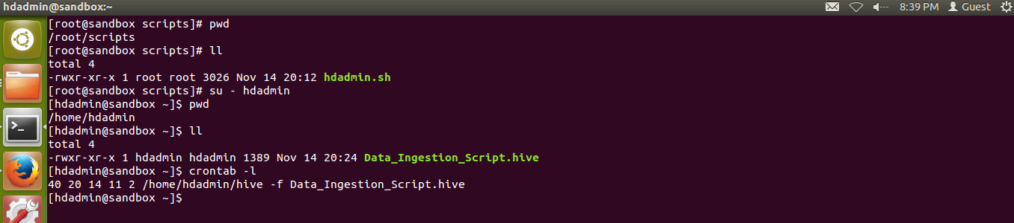

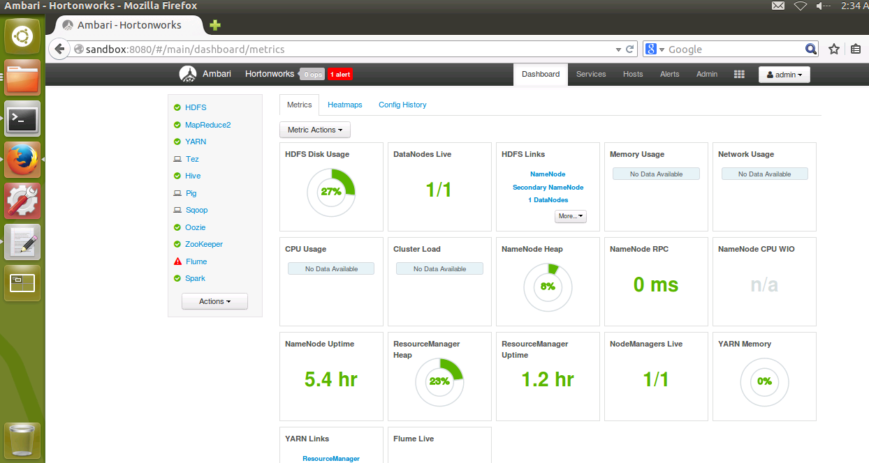

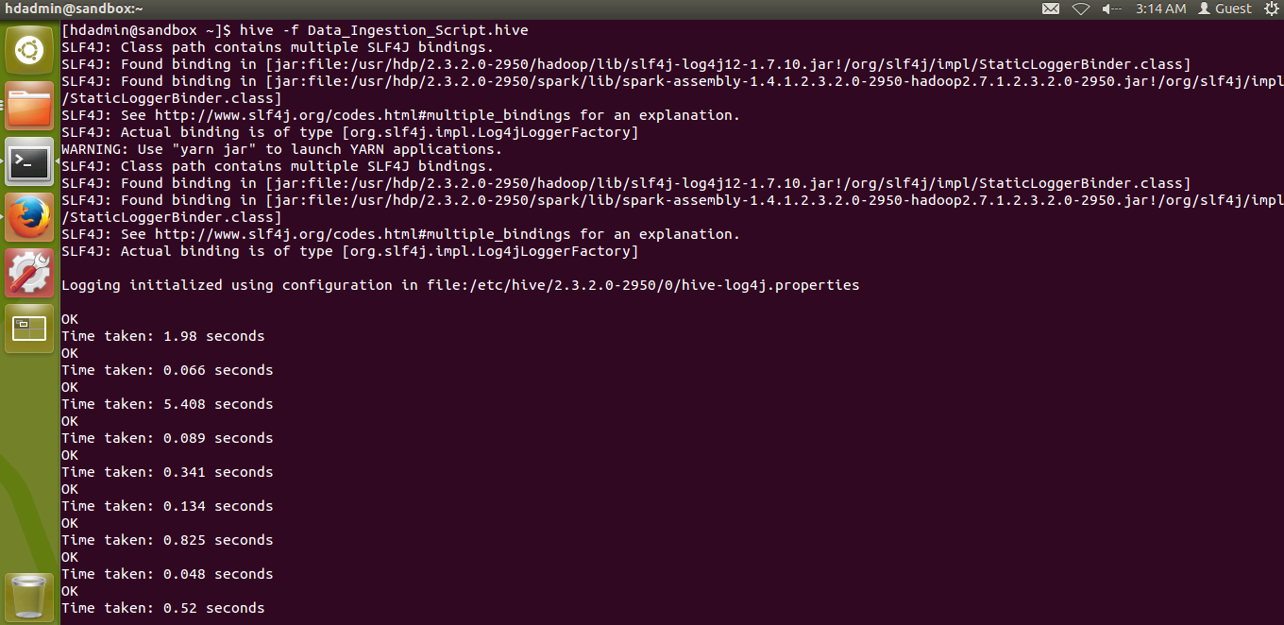

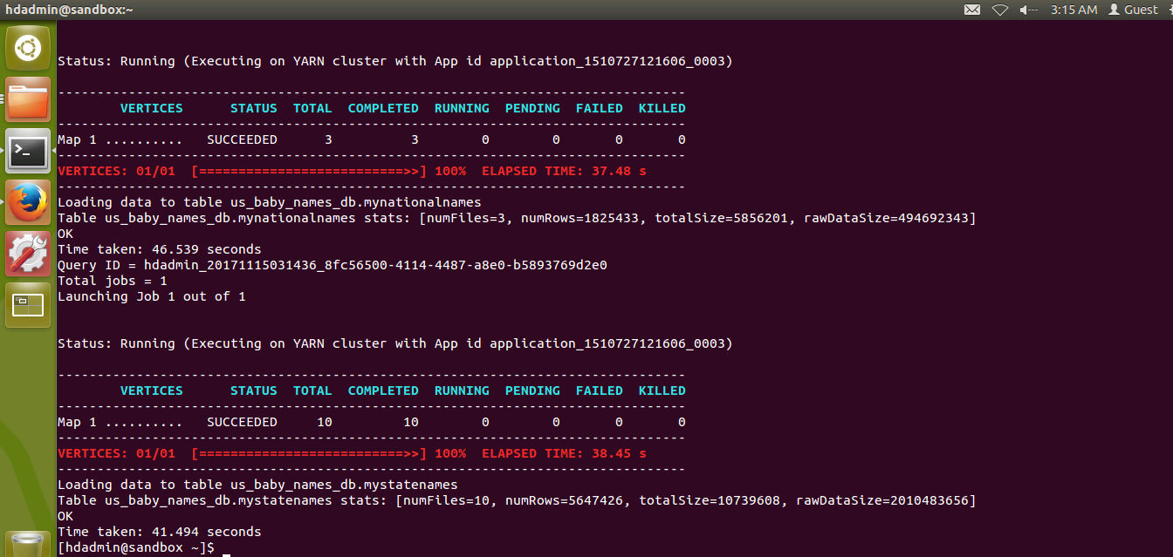

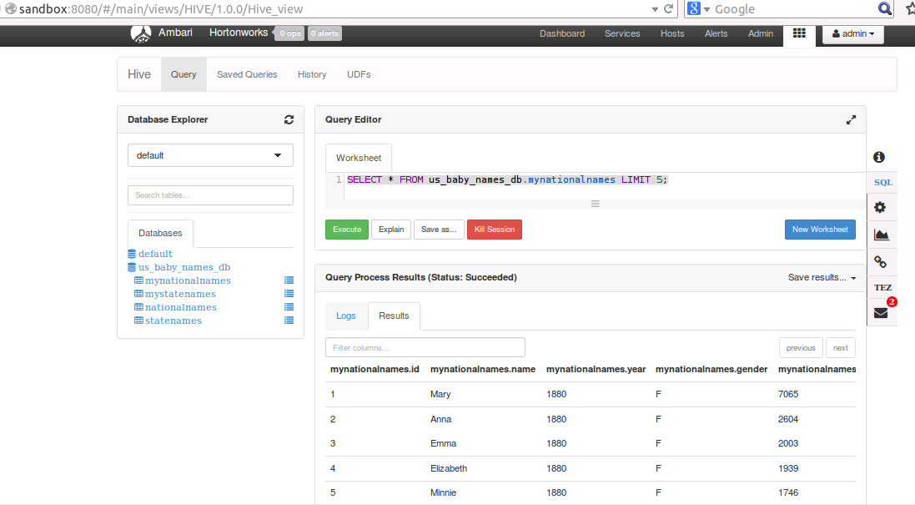

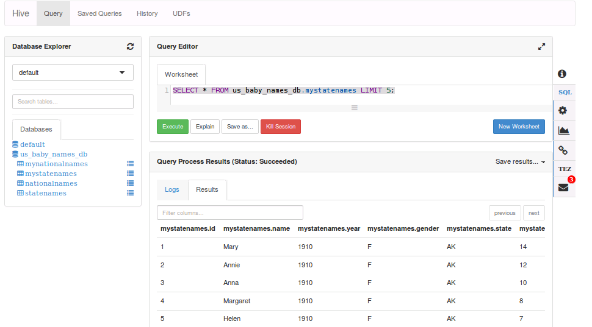

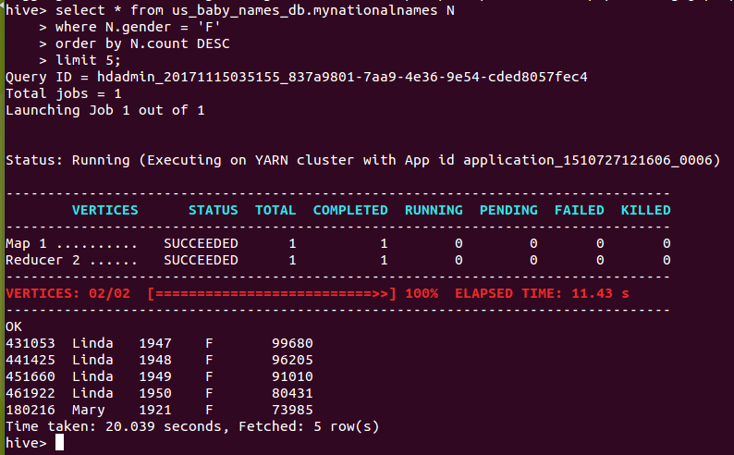

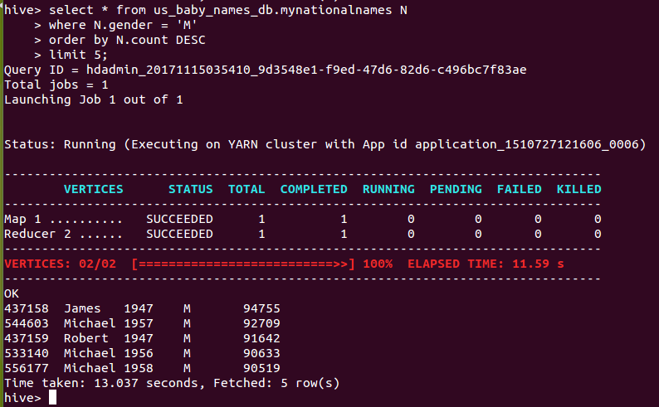

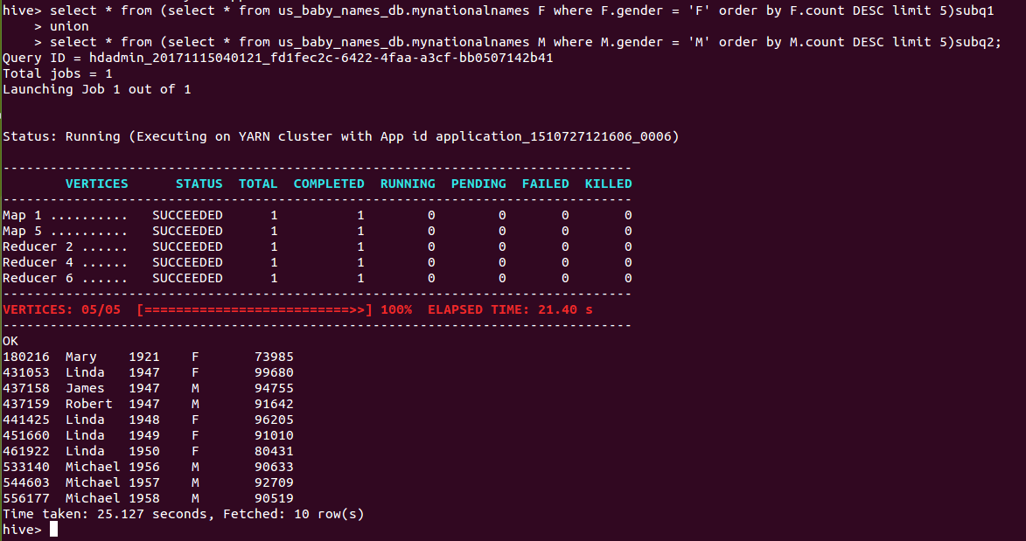

select * from (select * from us_baby_names_db.mynationalnames F where F.gender = 'F' order by F.count DESC limit 5)subq1

union

select * from (select * from us_baby_names_db.mynationalnames M where M.gender = 'M' order by M.count DESC limit 5)subq2;

OK

180216  Mary     1921       F              73985

431053  Linda     1947       F              99680

437158  James   1947       M            94755

437159  Robert  1947       M            91642

441425  Linda     1948       F              96205

451660  Linda     1949       F              91010

461922  Linda     1950       F              80431

533140  Michael                1956       M            90633

544603  Michael                1957       M            92709

556177  Michael                1958       M            90519

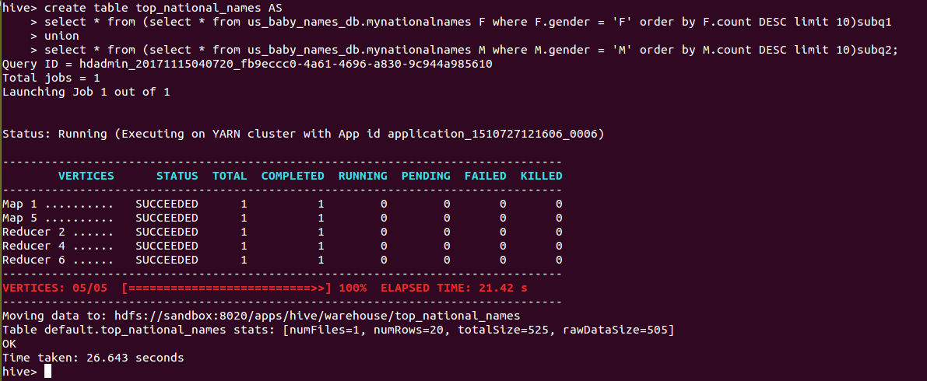

create table top_national_names AS

select * from (select * from us_baby_names_db.mynationalnames F where F.gender = 'F' order by F.count DESC limit 10)subq1

union

select * from (select * from us_baby_names_db.mynationalnames M where M.gender = 'M' order by M.count DESC limit 10)subq2;

insert into table top_national_names AS

select * from (select * from us_baby_names_db.mynationalnames F where F.gender = 'F' order by F.count DESC limit 10)subq1

union

select * from (select * from us_baby_names_db.mynationalnames M where M.gender = 'M' order by M.count DESC limit 10)subq2;

